目录

1.1登录 1

1.2 QQ登录 5

1.3 微信登录 7

1.4 注册 7

1.5 主页面 9

1.5.1 功能介绍 9

1.5.2 发现课程 12

1.5.3 日程安排 15

1.6 课程分类 18

1.7 我的学习 20

1.8 个人中心 23

1.9 课程详情界面 25

1.9.1 视频播放 25

1.9.2 课程介绍与教师介绍 28

1.9.3 课程大纲 30

1.10 个人中心详情界面 33

1.10.1 个人资料 35

1.10.2 历史记录 36

1.10.3 教学日历 36

**E-learning APP design report2**

**17301159 李智慧**

This report describes the display content, functional requirements, and design-related code of each page of the E-learning APP.

# 1.1登录

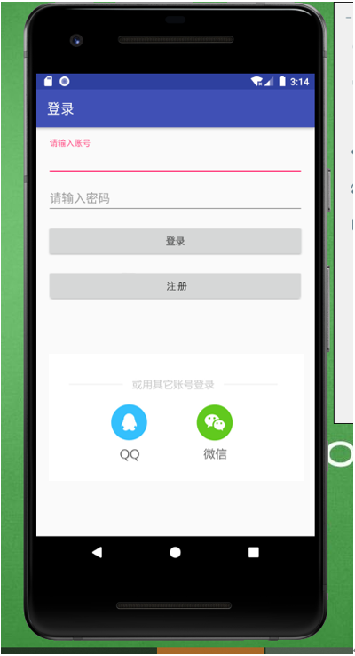

The user fills in the account and password, and clicks the "Login" button to log in. After verification, jump to the main page. New users need to register first and then log in. Click "Register" to jump to the registration page.

If the user does not enter an account number, the prompt "Please enter an account number" is displayed. If the user does not enter a password, the prompt "Please enter a password" is displayed.

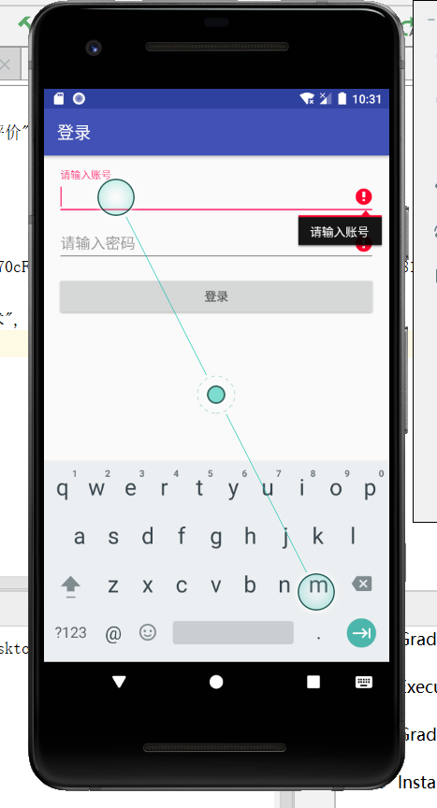

If the account and password entered by the user are correct, the login is successful. The interface during login is as follows:

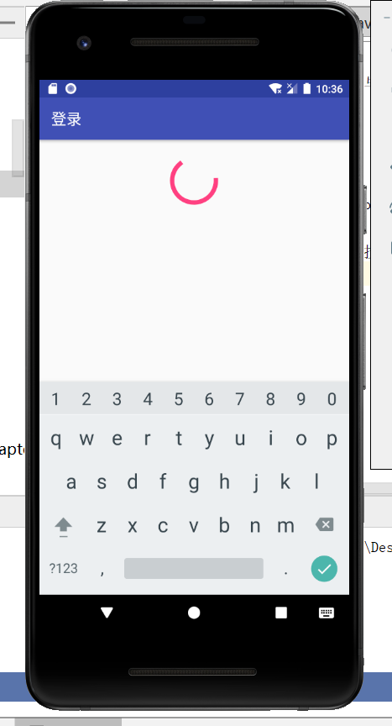

Here is a screenshot of some code.

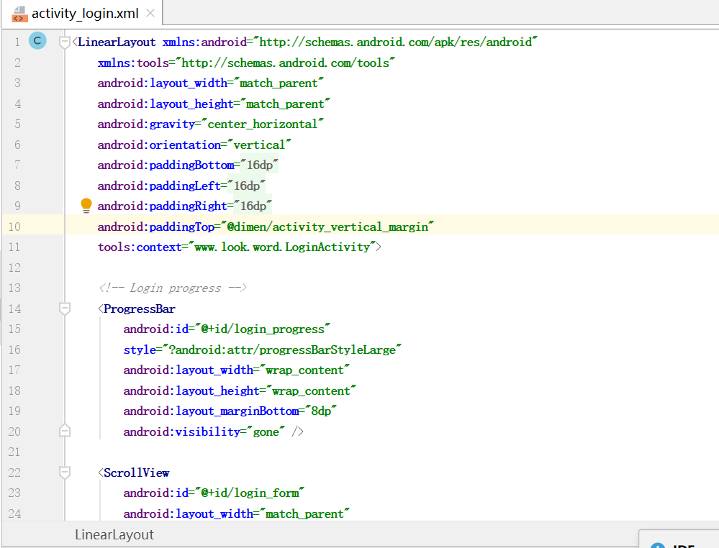

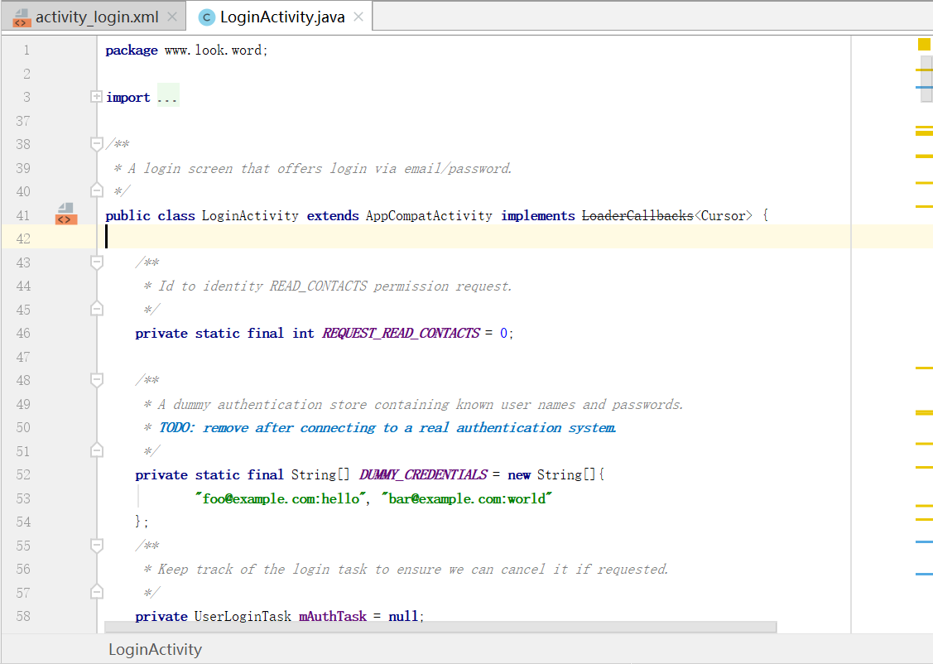

# 1.2 QQ登录

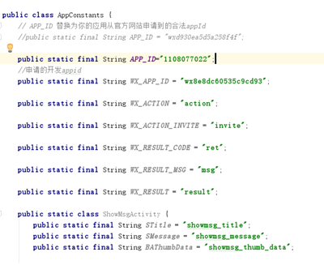

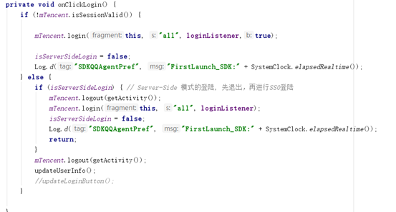

# 1.3 微信登录

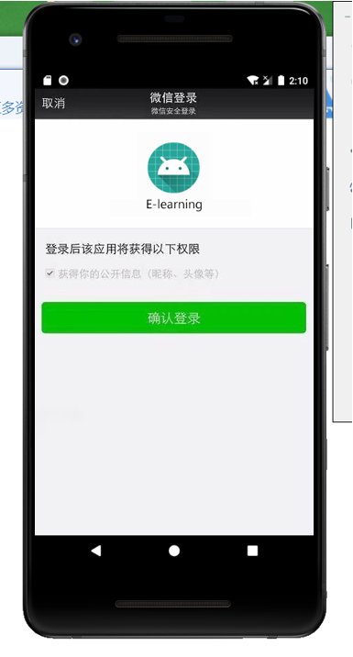

# 1.4 注册

The user can register after filling in the user name, password and confirmation password.

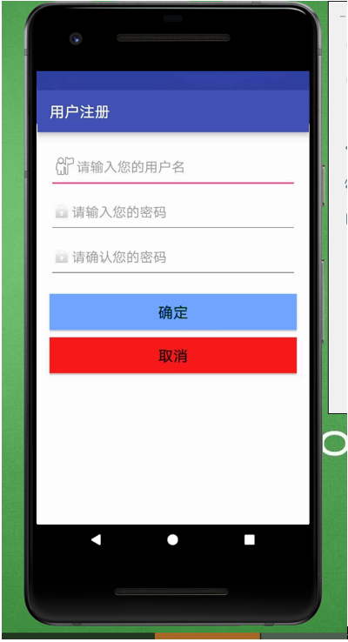

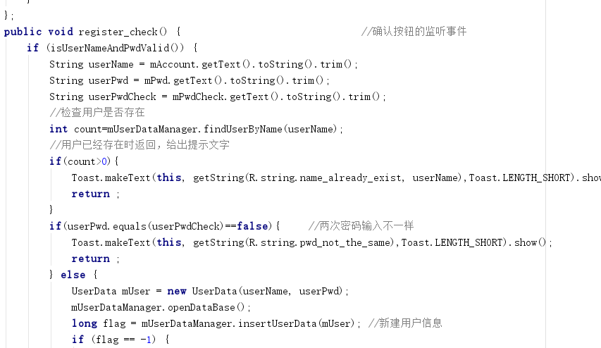

# 1.5 主页面

## 1.5.1 功能介绍

The head of the main page has two functions "Discovery Course" and "Schedule". Among them, "Discovered Courses" displays a list of courses, and the list of courses displays the name of the university offering the course, the name of the teacher, and the number of viewers. "Schedule" sorts according to the start time and displays a list of courses in turn.

Below the head is a carousel that displays course information and can also be advertised. Here I have inserted several landscape pictures as examples.

At the bottom are four main functions. They are "Main Page", "Course", "My Learning", and "Personal Center." These will be introduced in turn.

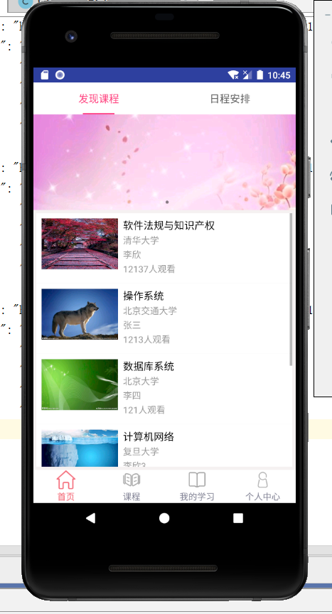 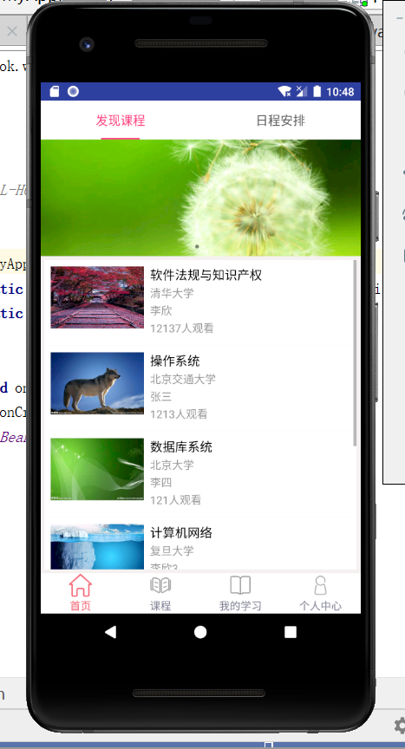

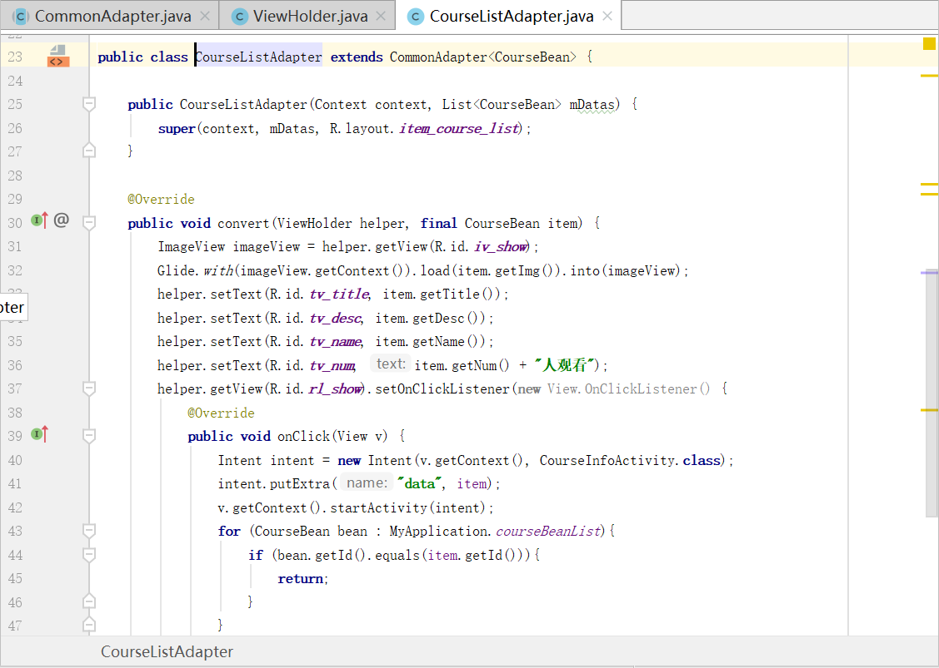

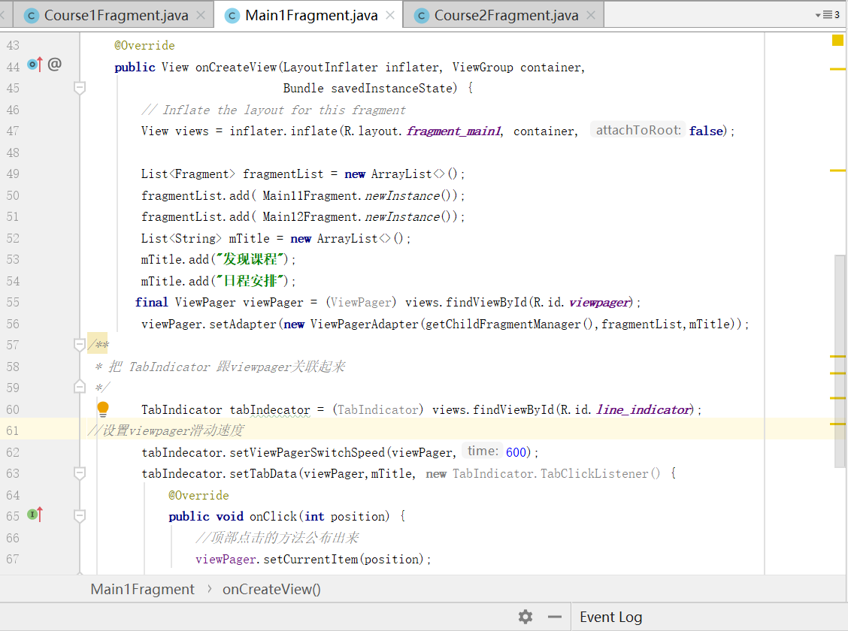

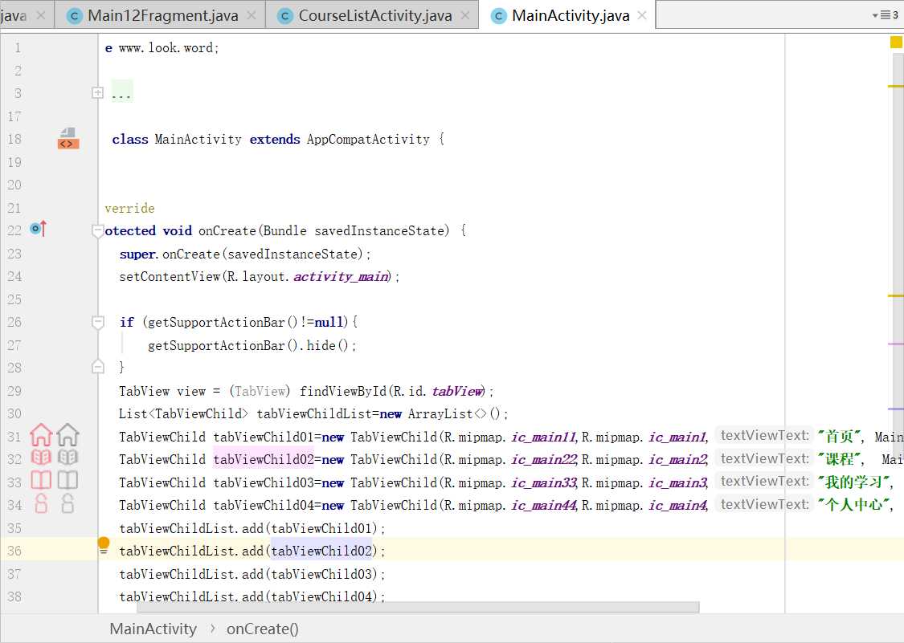

## 1.5.2 发现课程

The Discover Courses page displays a list of courses offered by the platform. In each display box, the picture is shown on the left, and the right is the university where the course is offered, the teachers and viewers. Click on the course to jump to the corresponding course details interface. The course details interface will be detailed later.



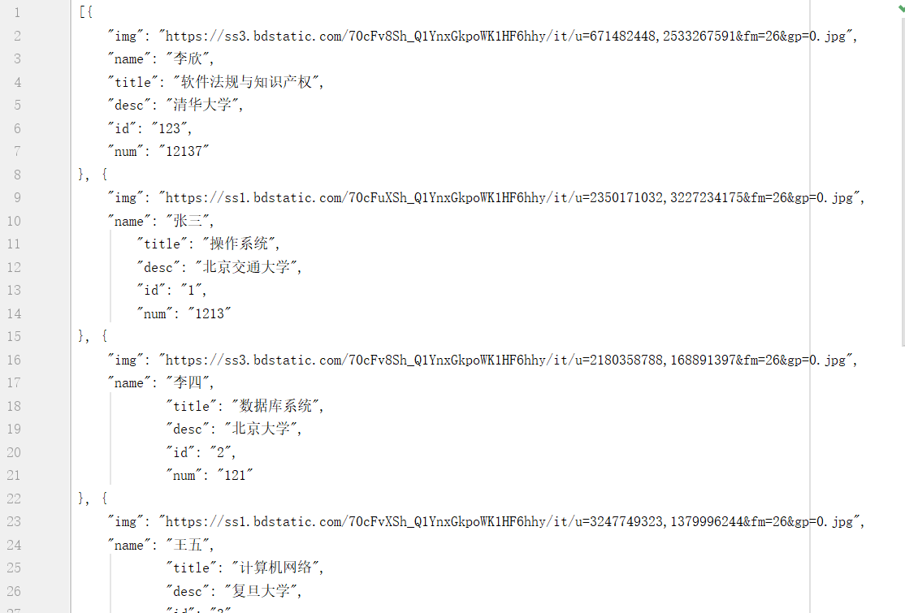



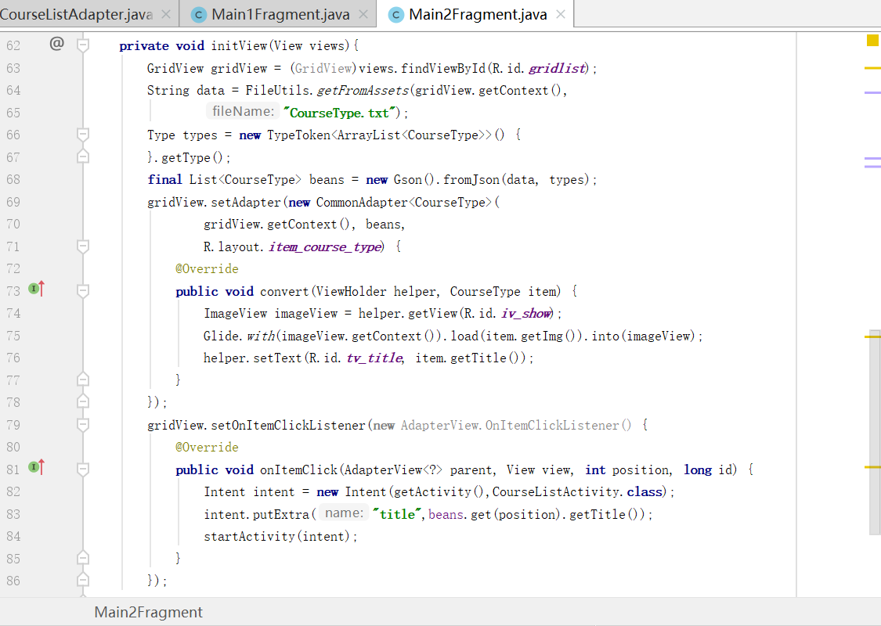

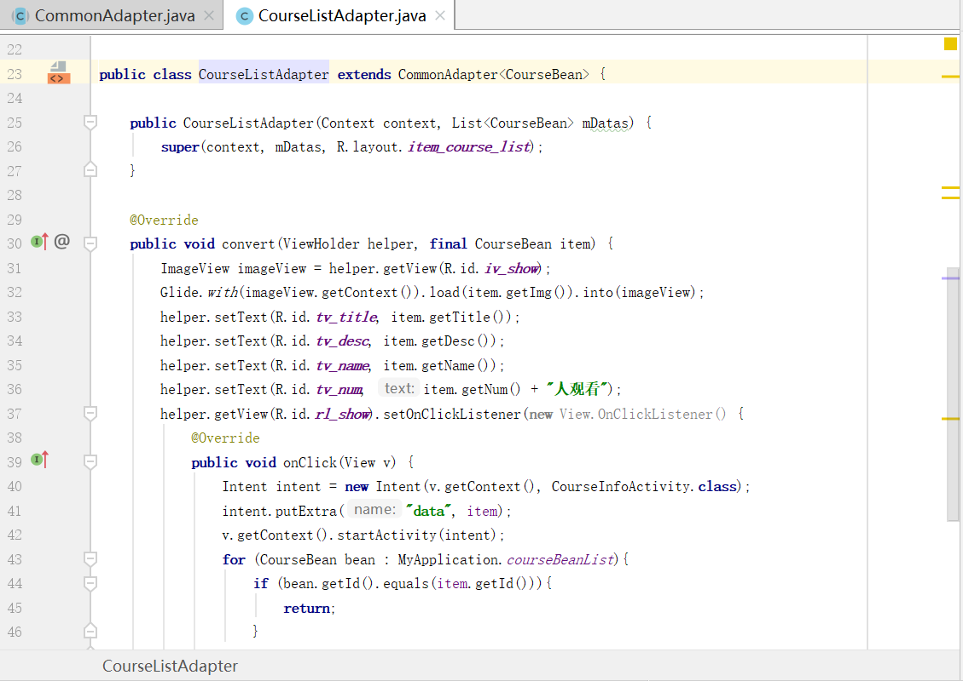

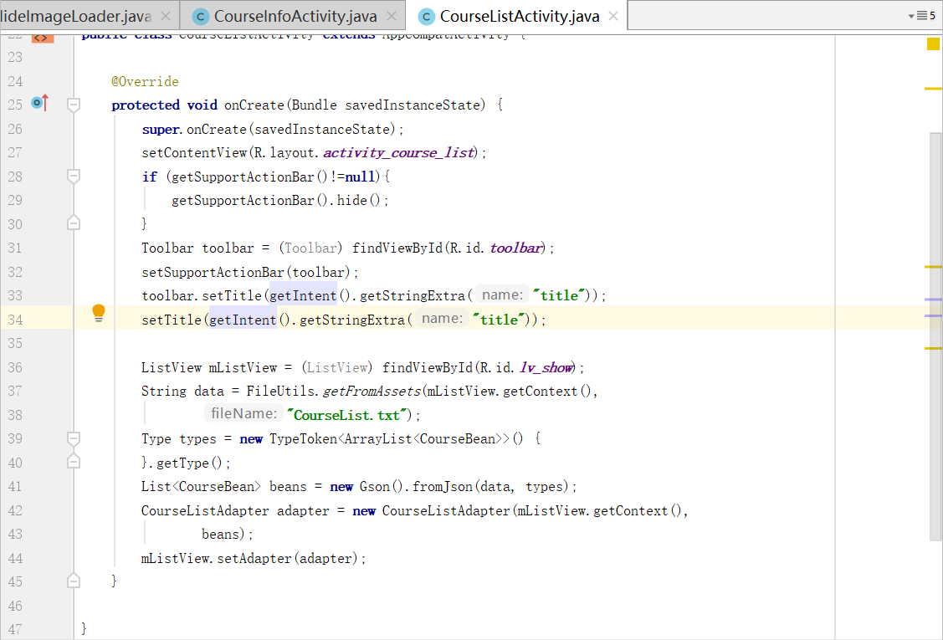

## 1.5.3 日程安排

The "Schedule" page displays a list of courses in order of the date of the course. For example: "Software Regulations and Intellectual Property" starts on January 2nd, and "Operating System" starts on January 3rd. In the course list, "Software Regulations and Intellectual Property" precedes "Operating Systems."

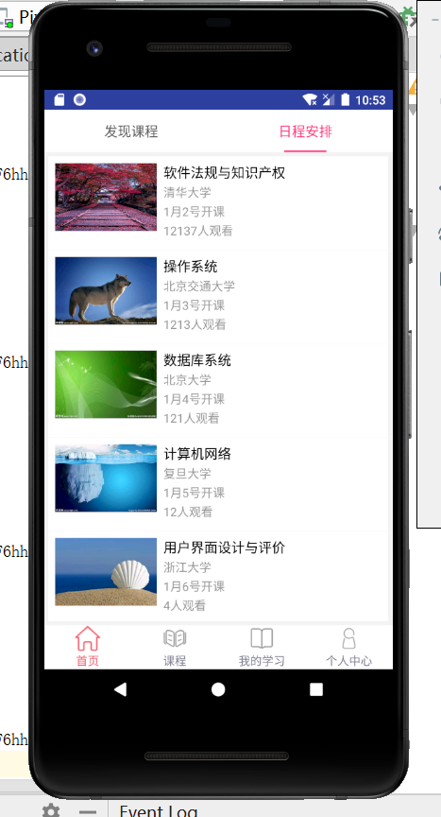







# 1.6 课程分类

"Course classification" is the classification of courses, such as: 20 postgraduate entrance examinations, exams are not linked, teacher columns, etc. Click on the corresponding column to jump to the corresponding course list page.

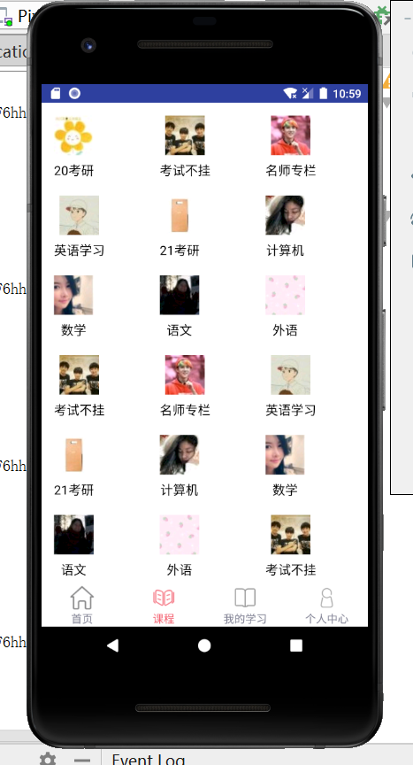

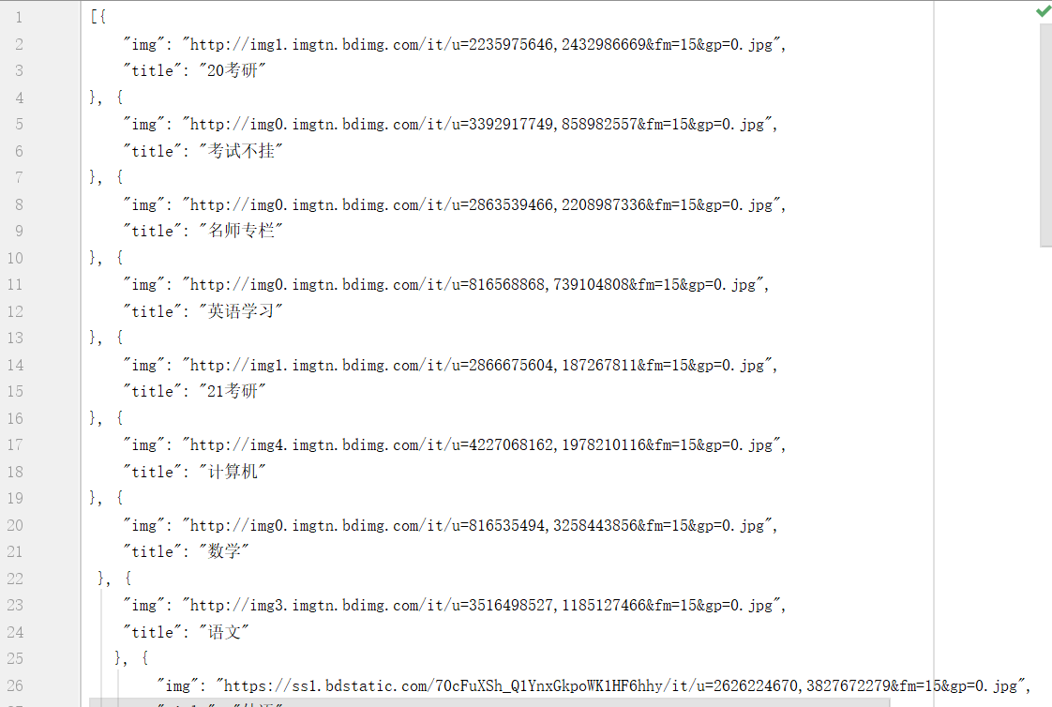

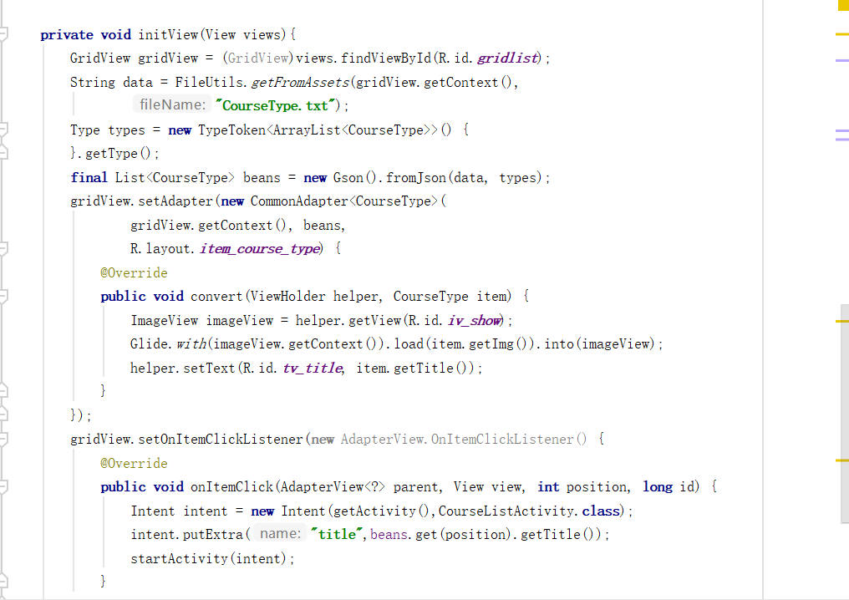

# 1.7 我的学习

"My Learning" can collect the courses that users have browsed in the order they are browsed and display them in turn on this page. This is done to make it easier for users to find the courses they have viewed.

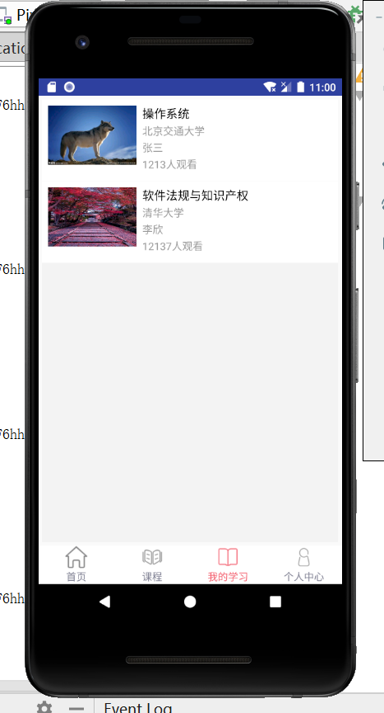

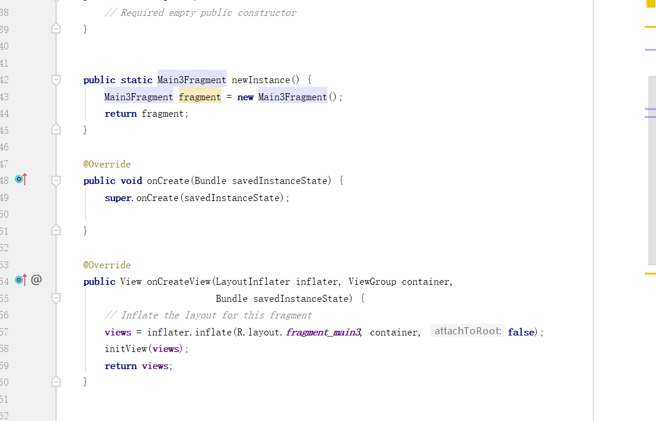

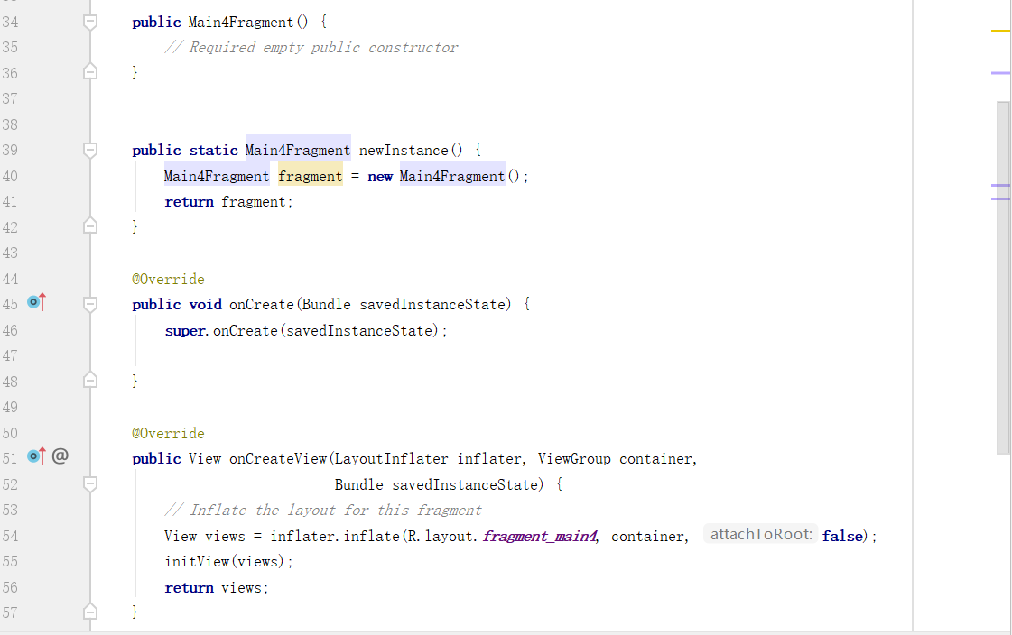

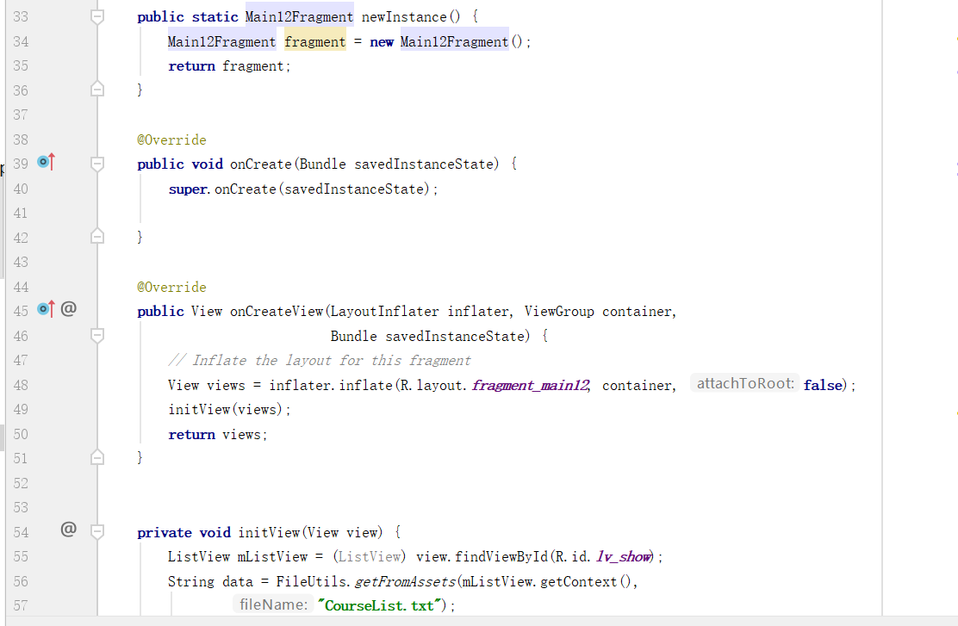

# 1.8 个人中心

The Personal Center page is the user's related information and settings interface. Includes "Profile", "History", "Teaching Calendar", "My Messages", "Invite Friends", "User Guide", "Settings" and more. Only the first three features have been developed so far.

、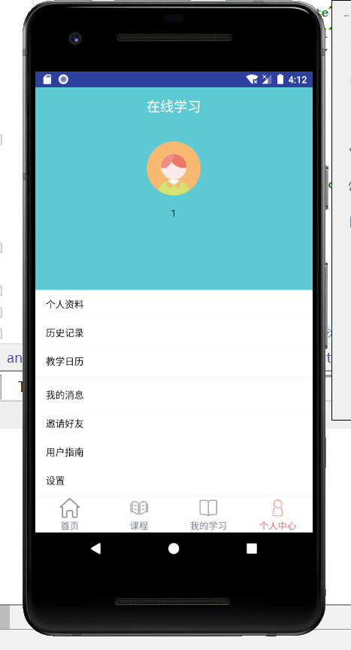

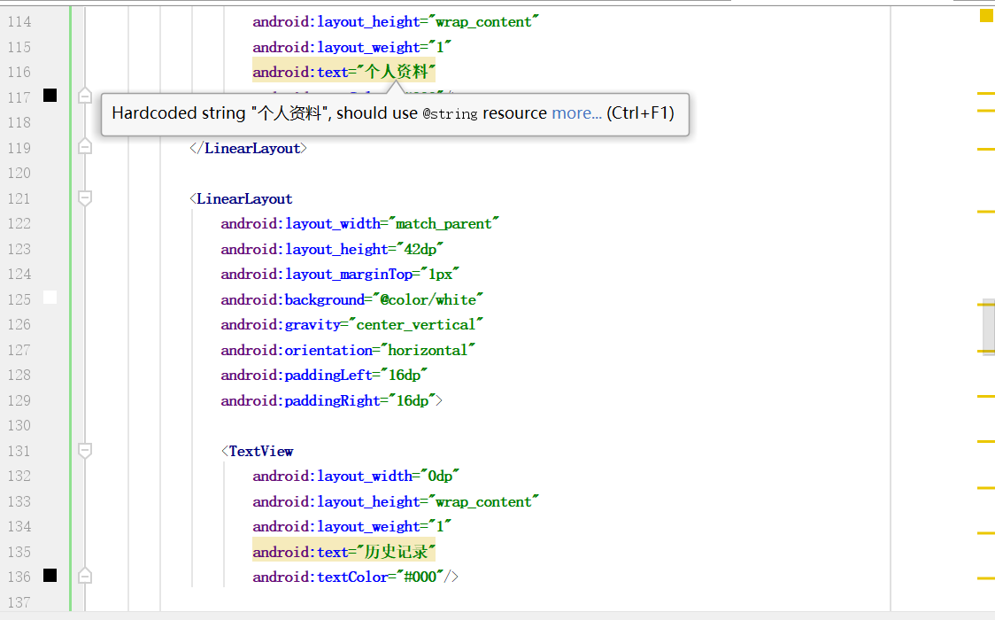

# 1.9 课程详情界面

## 1.9.1 视频播放

As mentioned earlier, after clicking a course in the course list, you can jump to the relevant course details interface. After entering this interface, the user can click to play the video.

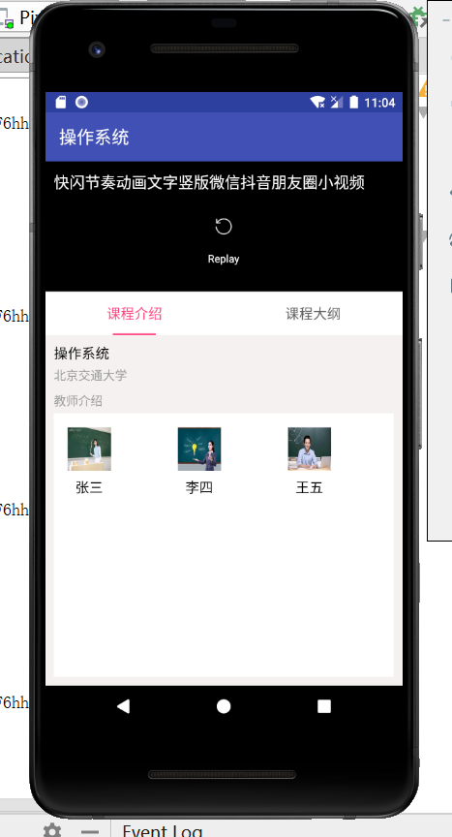 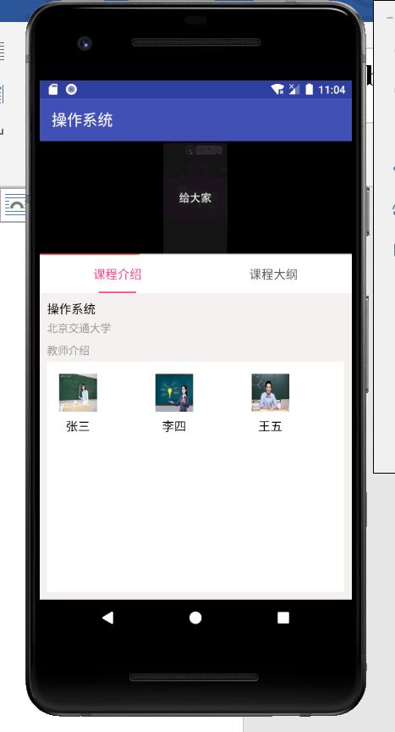

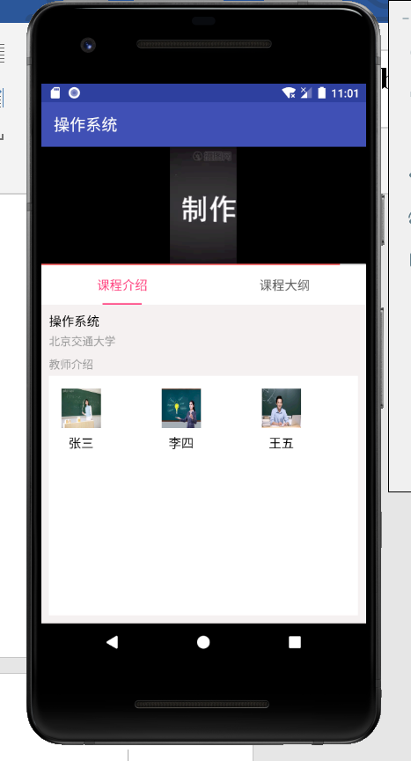

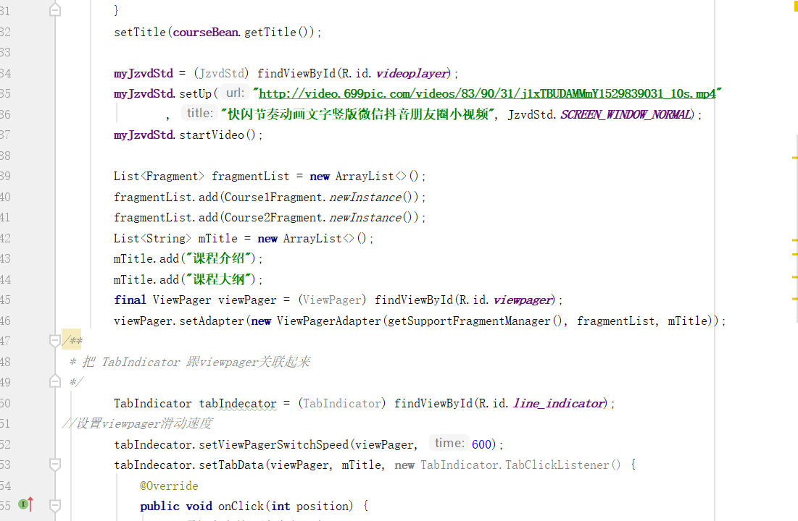

## 1.9.2 课程介绍与教师介绍

Below the video are "course introduction" and "course outline". Among them, the "course introduction" interface displays the course name, school establishment, and teacher introduction. "Teacher Introduction" contains teacher photo, teacher name. Click on the picture to see the teacher's introduction.

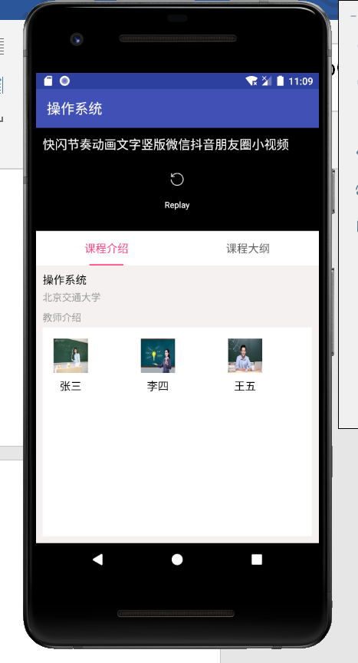 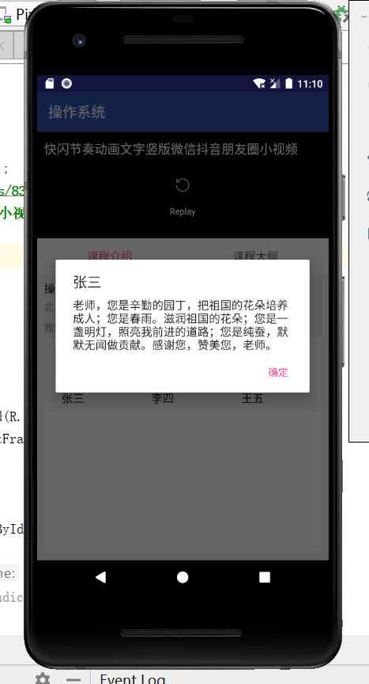

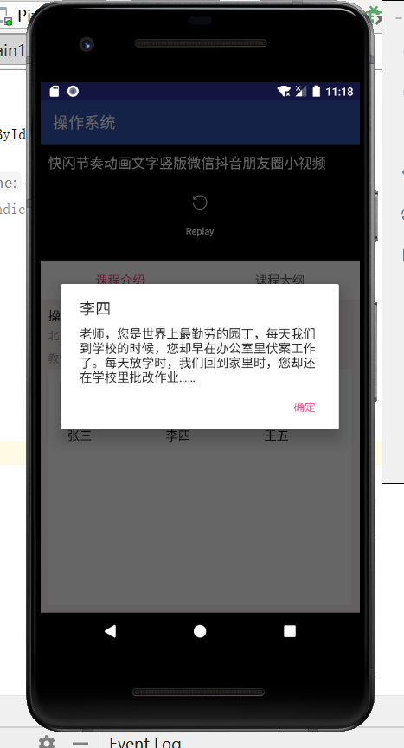 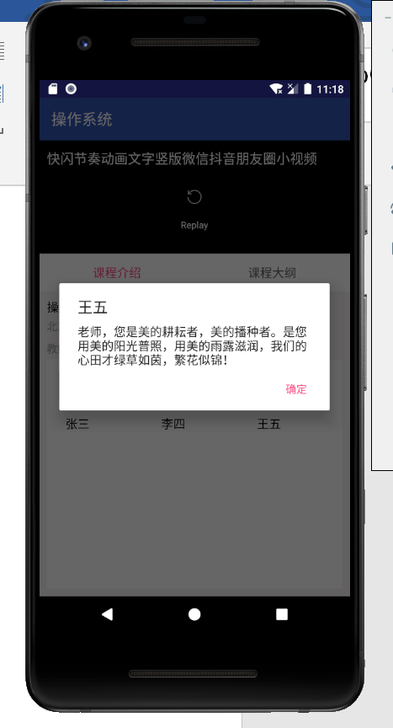

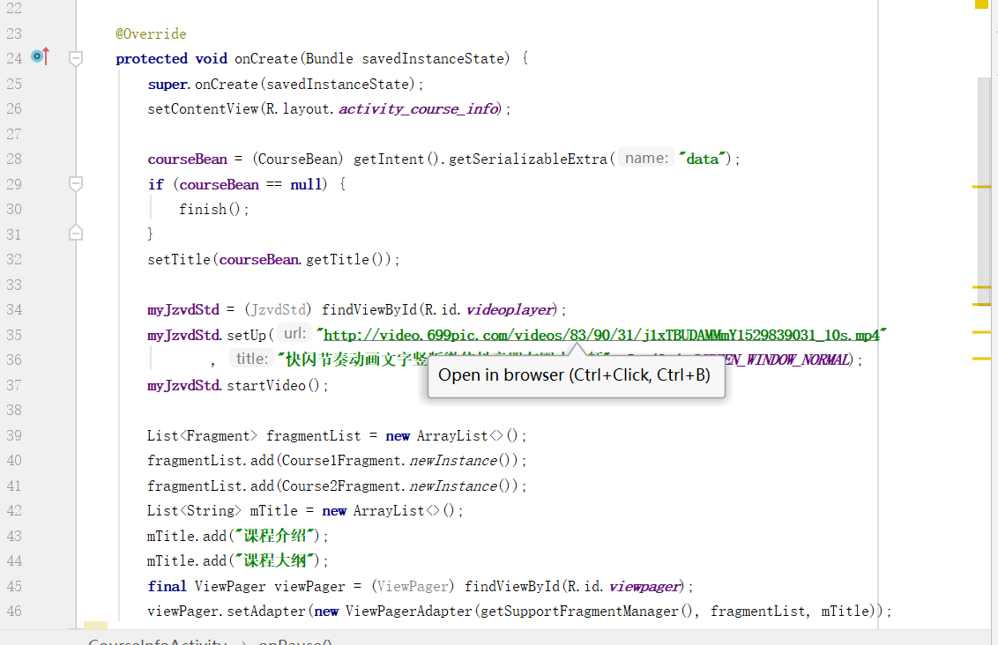

## 1.9.3 课程大纲

The Course Syllabus contains a series of videos of the course, here are a few small videos of my own collection. Click on the link to watch the video. As follows:

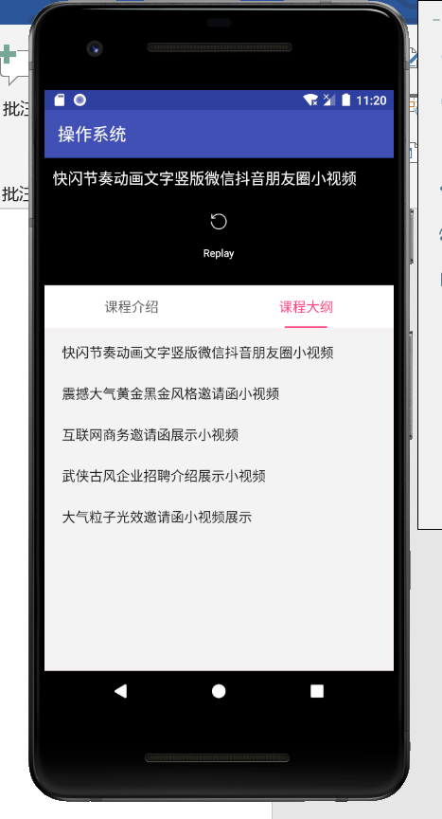 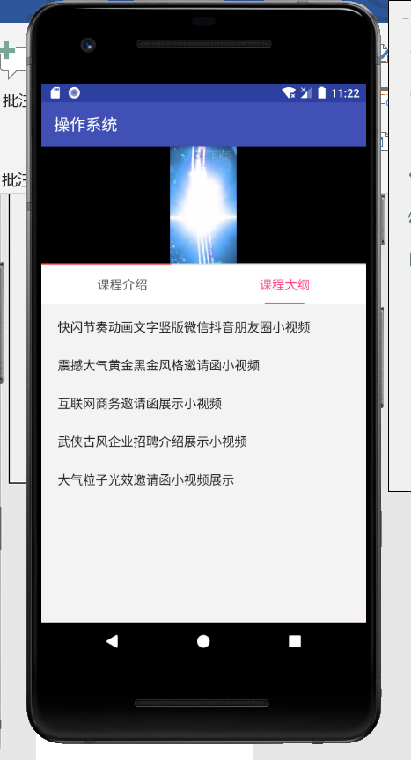

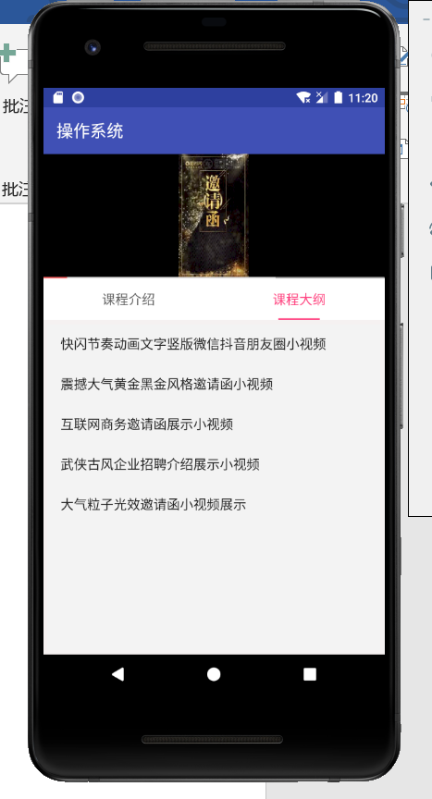 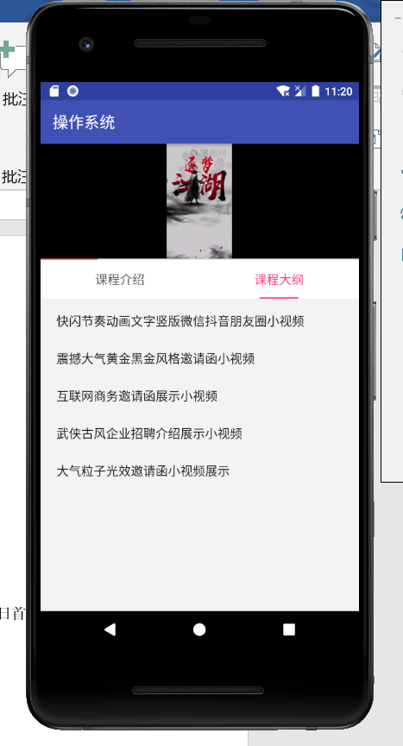

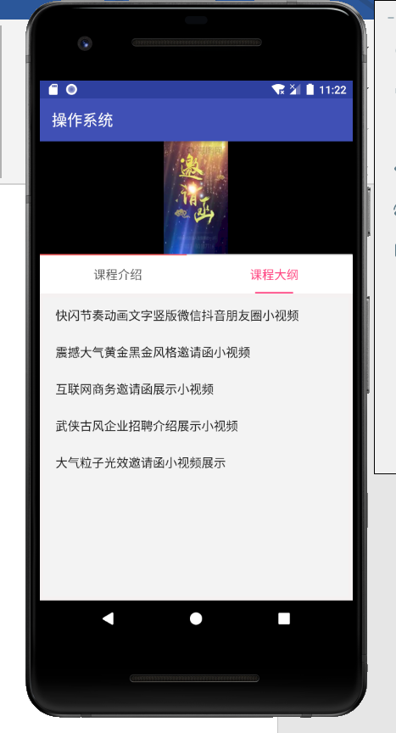

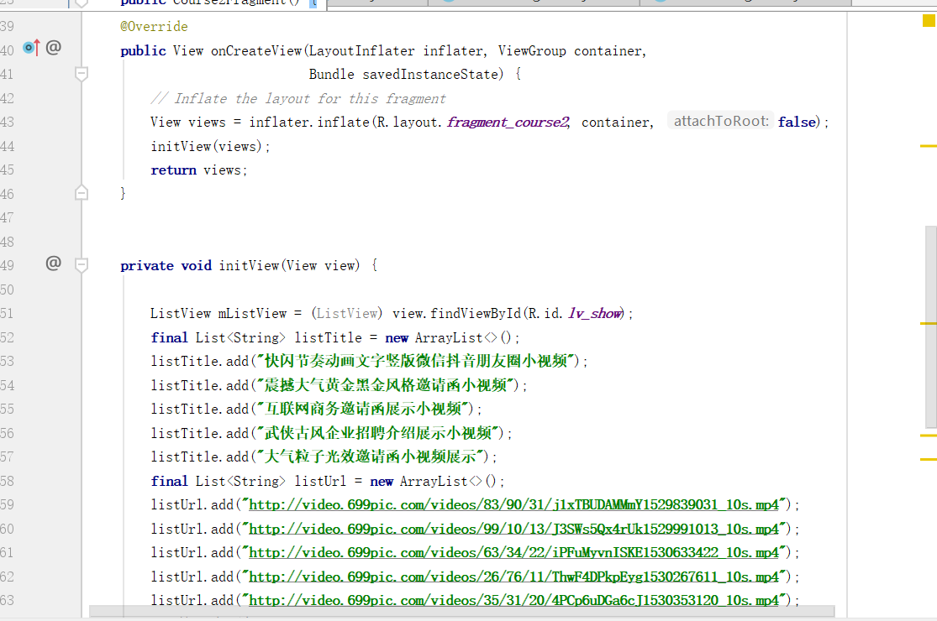

# 1.10 个人中心详情界面

The personal center interface is as follows:





## 1.10.1 个人资料

Click "Profile" to jump to the "Profile" screen. Display user's nickname, background image, gender, mobile phone, Email, address, click to modify information.

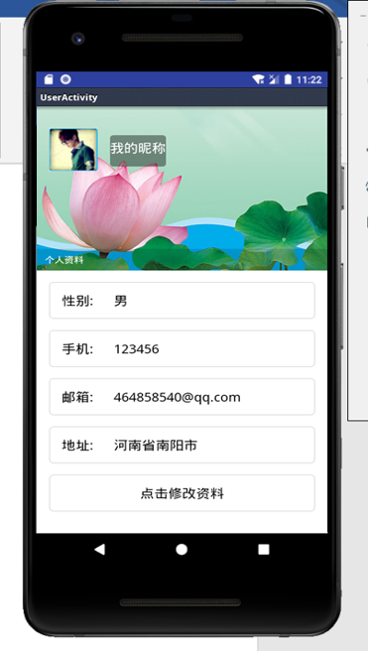

## 1.10.2 历史记录

Click "History" to jump to the "My Learning" interface, showing all the video records of the past browsing.



## 1.10.3 教学日历

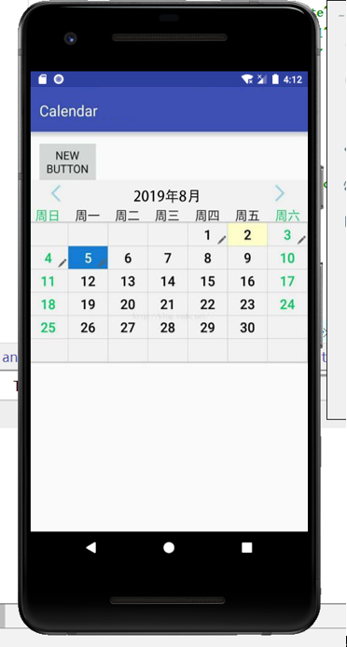ke

